Building Bridges Series III

Tentative Schedule
1. 10/17 God
2. 10/24 Jesus
3. 10/31 The Church of Jesus Christ
4. 11/7 Video: Bible vs. the Book of Mormon
5. 11/14 Reliability of Scripture
6. 11/28 Salvation, Grace & Atonement
7. 12/5 Heaven
8. 12/12 The Priesthoods & “Authority”
9. 12/19 Prophet, Bishop & Pastor
10. 1/2 Faith And Works
11. 1/9 Video: Lost Book of Abraham
12. 1/16 The Temple - Purpose & Role

The Heart of the Series

2 Timothy 4:1–2 - I charge you therefore before God and the Lord Jesus Christ, who will judge the living and the dead at His appearing and His kingdom: 2 Preach the word! Be ready in season and out of season. Convince, rebuke, exhort, with all longsuffering and teaching.

Building Bridges Series III

The Temple: Purpose & Role

LDS Doctrine

* “The Lord holds us responsible for going to and building Temples, that we may attend therein to the ordinances necessary for the salvation of the dead” (Wilford Woodruff, September 12, 1875, Journal of Discourses 18:114).

* “Why is it that we are so anxious to build temples? It is that we may attend to ordinances necessary for the salvation of the living and the dead, that we may be baptized for our ancestors who died without having the privilege of hearing and obeying the Gospel” (George Q. Cannon, December 3rd, 1871, Journal of Discourses 14:320).

* Whether you’ve seen the outside or the inside of a temple, in person or in pictures, or been to temples close to you or thousands of miles away, they all have one thing in common—that’s where Church members go to perform ordinances so they can one day return to our Heavenly Father’s presence, if they live worthily. That’s where Church members perform the same ordinances for those who’ve died, too. Temple ordinances are at the center of the gospel…We need the ordinances of the gospel to return to our Heavenly Father. We’re put on earth to serve out a probation, then to return to our Heavenly Father in exaltation. The only way to do that is through the ordinances of the temple. (https://www.lds.org/new-era/1987/02/preparing -for-the-temple-endowment?lang=eng)

Doctrines & Covenants 124
29–36, Baptisms for the dead are to be performed in temples; 37–44, The Lord’s people always build temples for the performance of holy ordinances;
33 For verily I say unto you, that after you have had sufficient time to build a house to me, wherein the ordinance of baptizing for the dead belongeth, and for which the same was instituted from before the foundation of the world, your baptisms for your dead cannot be acceptable unto me; 34 For therein are the keys of the holy priesthood ordained, that you may receive honor and glory. 35 And after this time, your baptisms for the dead, by those who are scattered abroad, are not acceptable unto me, saith the Lord… 38 For, for this cause I commanded Moses that he should build a tabernacle, that they should bear it with them in the wilderness, and to build a house in the land of promise, that those ordinances might be revealed which had been hid from before the world was. 39 Therefore, verily I say unto you, that your anointings, and your washings, and your baptisms for the dead, and your solemn assemblies, and your memorials for your sacrifices by the sons of Levi, and for your oracles in your most holy places wherein you receive conversations, and your statutes and judgments, for the beginning of the revelations and foundation of Zion, and for the glory, honor, and endowment of all her municipals, are ordained by the ordinance of my holy house, which my people are always commanded to build unto my holy name.

* Doctrine & Covenants Section 131
Instructions by Joseph Smith the Prophet, given at Ramus, Illinois, May 16 and 17, 1843.
1–4, Celestial marriage is essential to exaltation in the highest heaven;
1 In the celestial glory there are three heavens or degrees;
2 And in order to obtain the highest, a man must enter into this order of the priesthood [meaning the new and everlasting covenant of marriage];
3 And if he does not, he cannot obtain it.
4 He may enter into the other, but that is the end of his kingdom; he cannot have an increase.

The Atonement of Jesus Christ assures each of us that we will be resurrected and live forever. But if we are to live forever with our families in Heavenly Father’s presence, we must do all that the Savior commands us to do. This includes being baptized and confirmed and receiving the ordinances of the temple. (Gospel Principles, pg. 255)

Heavenly Father wants all of His children to return and live with Him. For those who died without baptism or the temple ordinances, He has provided a way for this to happen. He has asked us to perform ordinances for our ancestors in the temples. (Gospel Principles, pg. 255)

Temples of The Church of Jesus Christ of Latter-day Saints are special buildings dedicated to the Lord. Worthy Church members may go there to receive sacred ordinances and make covenants with God. Like baptism, these ordinances and covenants are necessary for our salvation. They must be performed in the temples of the Lord. (Gospel Principles, pg.255-256)

Many of our ancestors are among those who died without hearing about the gospel while on the earth. They now live in the spirit world (see chapter 41 in this book). There they are taught the gospel of Jesus Christ. Those who have accepted the gospel are waiting for the temple ordinances to be performed for them. As we perform these ordinances in the temple for our ancestors, we can share their joy. (Gospel Principles, pg. 257)

* The Church of Jesus Christ of Latter Day Saints Video:
Temples are a Beacon – No sacrifice is too great to obtain the blessings available in Holy
Temples. (https://www.lds.org/youth/learn/yw/ordinances-covenants/temple?lang=eng# video=temples-are-a-beacon)

LDS Temple Design - after the manner of the temple of Solomon (2 Nephi 5:16)
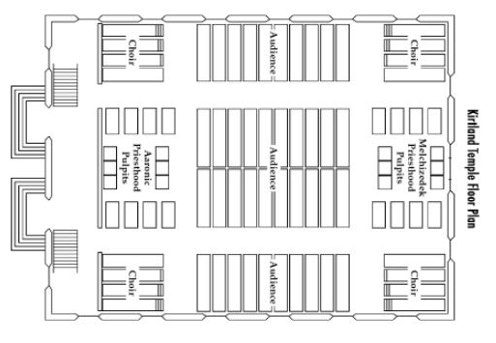
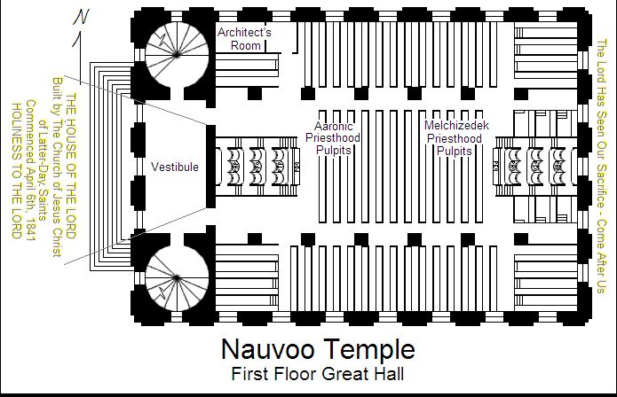

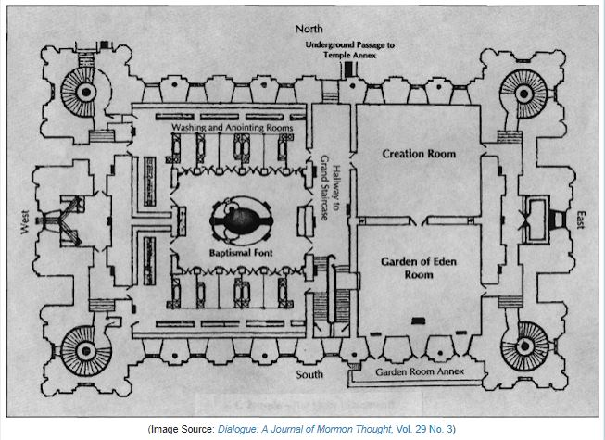
Salt Lake City Temple Floor Plan

Biblical Doctrine

The Tabernacle
* Deuteronomy 12:1–2 - “These are the statutes and judgments which you shall be careful to observe in the land which the Lord God of your fathers is giving you to possess, all the days that you live on the earth. 2 You shall utterly destroy all the places where the nations which you shall dispossess served their gods, on the high mountains and on the hills and under every green tree.
* Deuteronomy 12:13–14 - Take heed to yourself that you do not offer your burnt offerings in every place that you see; 14 but in the place which the Lord chooses, in one of your tribes, there you shall offer your burnt offerings, and there you shall do all that I command you.
* Deuteronomy 12:18 - But you must eat them before the Lord your God in the place which the Lord your God chooses, you and your son and your daughter, your male servant and your female servant, and the Levite who is within your gates; and you shall rejoice before the Lord your God in all to which you put your hands.

The Temple
* 2 Chronicles 3:1 - Now Solomon began to build the house of the Lord at Jerusalem on Mount Moriah, where the Lord had appeared to his father David, at the place that David had prepared on the threshing floor of Ornan the Jebusite.
* Genesis 22:1–2 - Now it came to pass after these things that God tested Abraham, and said to him, “Abraham!” And he said, “Here I am.” 2 Then He said, “Take now your son, your only son Isaac, whom you love, and go to the land of Moriah, and offer him there as a burnt offering on one of the mountains of which I shall tell you.”

Video: Bible vs. The Book Of Mormon (Temples)
* The Temple Mount, Western wall (Wailing wall), Jerusalem is 2,200 years old.
* It was built by Herod The Great, and destroyed by Titus in 70 AD.
* And I, Nephi, did build a temple; and I did construct it after the manner of the temple of Solomon save it were not built of so many precious things; for they were not to be found upon the land, wherefore, it could not be built like unto Solomon’s temple. But the manner of the construction was like unto the temple of Solomon; and the workmanship thereof was exceedingly fine. (Book of Mormon, 2 Nephi 5:16)
* “Any person who studies the Bible understands that the centrality of worship here in Jerusalem on the Temple Mount. The very idea of a temple anywhere other than Mount Moriah is a total impossibility. Jews are literally not allowed to erect a temple anywhere in the world except for right here.” (Rabbi Chaim Richman, Director, Temple Institute, Jerusalem)
* BOM clearly identifies Lehi as a descendant of Joseph. (Tribe of Joseph, Not Levi)
* 2 Nephi 5 – Lehi appoints his two sons as priests to serve in the temple they had built.
* And it came to pass that I, Nephi, did consecrate Jacob and Joseph, that they should be priests and teachers over the land of my people. (Book of Mormon, 2 Nephi 5:26)
* “The men who are serving in the Holy Temple are all descendants of Aaron, lineal descendants of Aaron.” (Rabbi Chaim Richman, Director, Temple Institute, Jerusalem)
* The Book of Mormon claim causes a problem because appointing priests who were not Aaron Levites was expressly forbidden in the Old Testament!
Conclusion
* The building of temples in other locations other than the Temple Mount and the appointment of men as priests from outside the lineage of Aaron from tribe of Levi are UNLAWFUL according to the Bible.

Tabernacle & Temple Diagrams

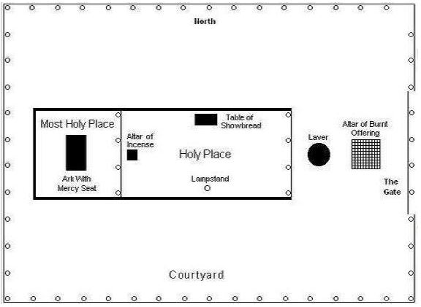
Moses’ Tabernacle

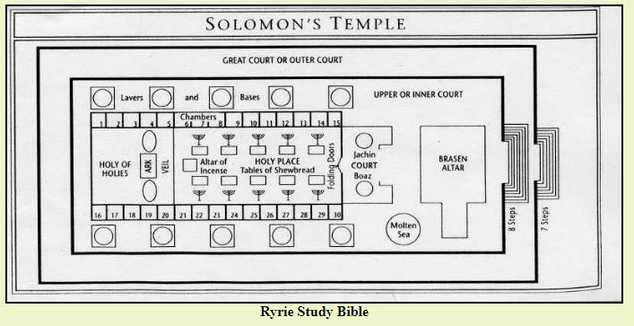

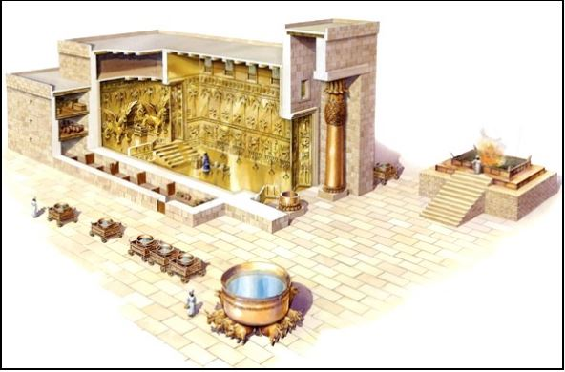

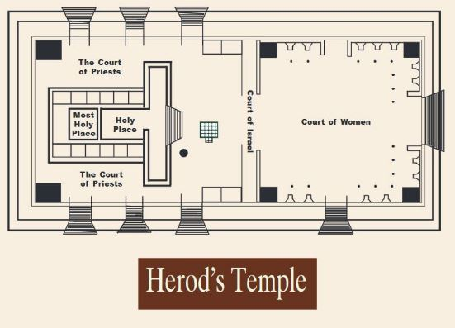

1 Kings 7:23–26 - And he made the Sea of cast bronze, ten cubits from one brim to the other; it was completely round. Its height was five cubits, and a line of thirty cubits measured its circumference. 24 Below its brim were ornamental buds encircling it all around, ten to a cubit, all the way around the Sea. The ornamental buds were cast in two rows when it was cast. 25 It stood on twelve oxen: three looking toward the north, three looking toward the west, three looking toward the south, and three looking toward the east; the Sea was set upon them, and all their back parts pointed inward. 26 It was a handbreadth thick; and its brim was shaped like the brim of a cup, like a lily blossom. It contained two thousand baths.

Exodus 30:18 - “You shall also make a laver of bronze, with its base also of bronze,
for washing. You shall put it between the tabernacle of meeting and the altar. And you shall put water in it,

1 Kings 7:38–39 - Then he made ten lavers of bronze; each laver contained forty baths, and each laver was four cubits. On each of the ten carts was a laver. 39 And he put five carts on the right side of the house, and five on the left side of the house. He set the Sea on the right side of the house, toward the southeast.

Conclusion
* There were NO Baptisteries in the Biblical Tabernacle & Temples.
* There were NO Sealing Rooms in the Biblical Tabernacle & Temples.
* There were NO Garden Rooms or Celestial Rooms in the Biblical Tabernacle & Temples.
* There is No Biblical basis for the LDS Temples or for the ordinances performed in
them to include endowments, sealing of marriages and baptisms for the dead.

New Testament Teaching
Hebrews 8:1–13 - Now this is the main point of the things we are saying: We have such a High Priest, who is seated at the right hand of the throne of the Majesty in the heavens, 2 a Minister of the sanctuary and of the true tabernacle which the Lord erected, and not man. 3 For every high priest is appointed to offer both gifts and sacrifices. Therefore it is necessary that this One also have something to offer. 4 For if He were on earth, He would not be a priest, since there are priests who offer the gifts according to the law; 5 who serve the copy and shadow of the heavenly things, as Moses was divinely instructed when he was about to make the tabernacle. For He said, “See that you make all things according to the pattern shown you on the mountain.” 6 But now He has obtained a more excellent ministry, inasmuch as He is also Mediator of a better covenant, which was established on better promises… 7 For if that first covenant had been faultless, then no place would have been sought for a second… 13 In that He says, “A new covenant,” He has made the first obsolete. Now what is becoming obsolete and growing old is ready to vanish away.

Hebrews 9:1–12 - Then indeed, even the first covenant had ordinances of divine service and the earthly sanctuary. 2 For a tabernacle was prepared: the first part, in which was the lampstand, the table, and the showbread, which is called the sanctuary; 3 and behind the second veil, the part of the tabernacle which is called the Holiest of All, 4 which had the golden censer and the ark of the covenant overlaid on all sides with gold, in which were the golden pot that had the manna, Aaron’s rod that budded, and the tablets of the covenant; 5 and above it were the cherubim of glory overshadowing the mercy seat. Of these things we cannot now speak in detail. 6 Now when these things had been thus prepared, the priests always went into the first part of the tabernacle, performing the services. 7 But into the second part the high priest went alone once a year, not without blood, which he offered for himself and for the people’s sins committed in ignorance; 8 the Holy Spirit indicating this, that the way into the Holiest of All was not yet made manifest while the first tabernacle was still standing. 9 It was symbolic for the present time in which both gifts and sacrifices are offered which cannot make him who performed the service perfect in regard to the conscience—10 concerned only with foods and drinks, various washings, and fleshly ordinances imposed until the time of reformation. 11 But Christ came as High Priest of the good things to come, with the greater and more perfect tabernacle not made with hands, that is, not of this creation. 12 Not with the blood of goats and calves, but with His own blood He entered the Most Holy Place once for all, having obtained eternal redemption.

Hebrews 10:19–20 - Therefore, brethren, having boldness to enter the Holiest by the blood of Jesus, 20 by a new and living way which He consecrated for us, through the veil, that is, His flesh,

1 Corinthians 3:16–17 - Do you not know that you are the temple of God and that the Spirit of God dwells in you? 17 If anyone defiles the temple of God, God will destroy him. For the temple of God is holy, which temple you are.

Ephesians 2:19–22 - Now, therefore, you are no longer strangers and foreigners, but fellow citizens with the saints and members of the household of God, 20 having been built on the foundation of the apostles and prophets, Jesus Christ Himself being the chief cornerstone, 21 in whom the whole building, being fitted together, grows into a holy temple in the Lord, 22 in whom you also are being built together for a dwelling place of God in the Spirit.

2 Corinthians 6:16 - And what agreement has the temple of God with idols? For you are the temple of the living God. As God has said: “I will dwell in them And walk among them. I will be their God, And they shall be My people.”

